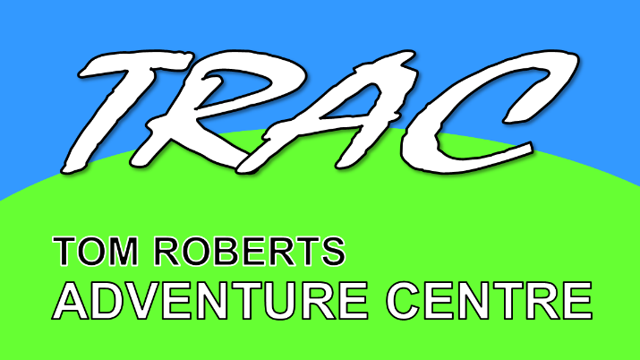
Tom Roberts Adventure Centre
Yates Farm Malswick
Newent Gloucestershire
GL18 1HE

www.tracnewent.org.uk
treasurer@tracnewent.org.uk

Tel: 01531 822606

TOM ROBERTS ADVENTURE CENTRE LIMITED GIFT AID FORM

I would like to make a donation to Tom Roberts Adventure Centre using Gift Aid.

First Name(s): Click or tap here to enter first name(s)
Surname: Click or tap here to enter surname

Address Line 1: Click or tap here to enter text.
Address Line 2: Click or tap here to enter text
Address Line 3: Click or tap here to enter text
Address Line 3: Click or tap here to enter text
Address Line 3: Click or tap here to enter text
Post Code: Click or tap here to enter postcode

Date: Click or tap here to enter date

Please click to mark all the appropriate boxes below:

☐ I wish to commit to making a regular donation of £ Click or tap here to enter amount per month to Tom Roberts Adventure Centre. Please send me a standing order form.
☐ I wish to make a one-off donation of £ Click or tap here to enter amount to Tom Roberts Adventure Centre.
☐ I wish all donations I have made, and will make in the future, to Tom Roberts Adventure Centre to be Gift Aided until I notify you otherwise in writing.
☐ I would like to receive details of Friends of TRAC

Please return this form to the email address above or print out and send to:

Graham Highton, Tom Roberts Adventure Centre, Yates Farm, Malswick, Newent, Glos., GL18 1HE

N.B. to qualify for Gift Aid, what you pay in income tax or capital gains tax must at least equal the amount Tom Roberts Adventure Centre will claim in the tax year (currently that means 28% of the gross equivalent of every £1 you donate). If you have not been charged sufficient tax to cover the Income Tax deducted from these Gift Aid donations, you are responsible for paying any difference.

